OUTPUT:

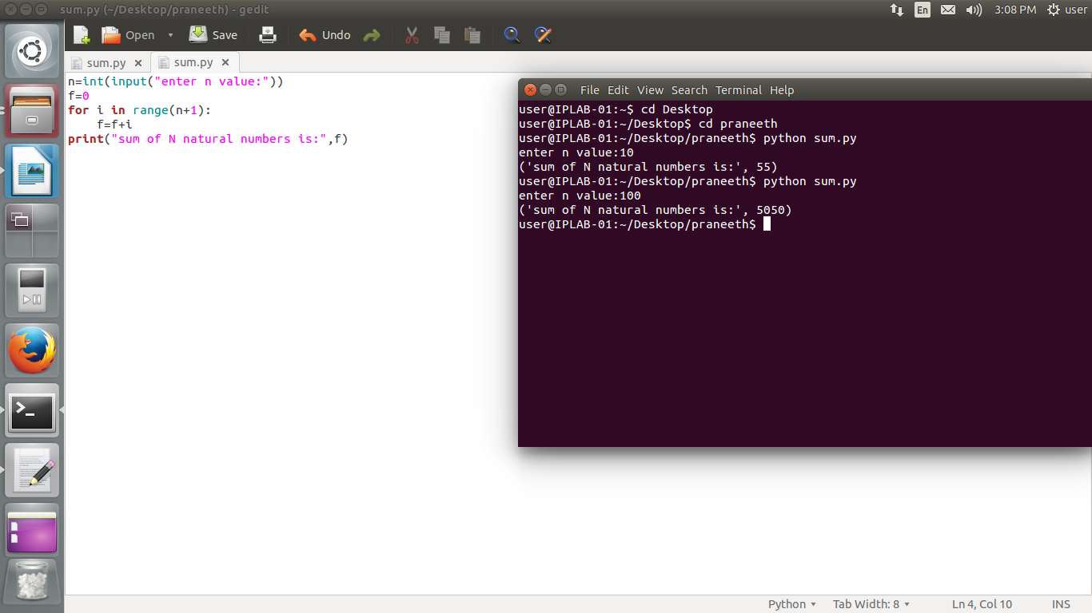

SOURCE CODE:

n=int(input("enter n value:"))

f=0

for i in range(n+1):

f=f+i

("sum of N natural numbers is:",f)

OUTPUT:

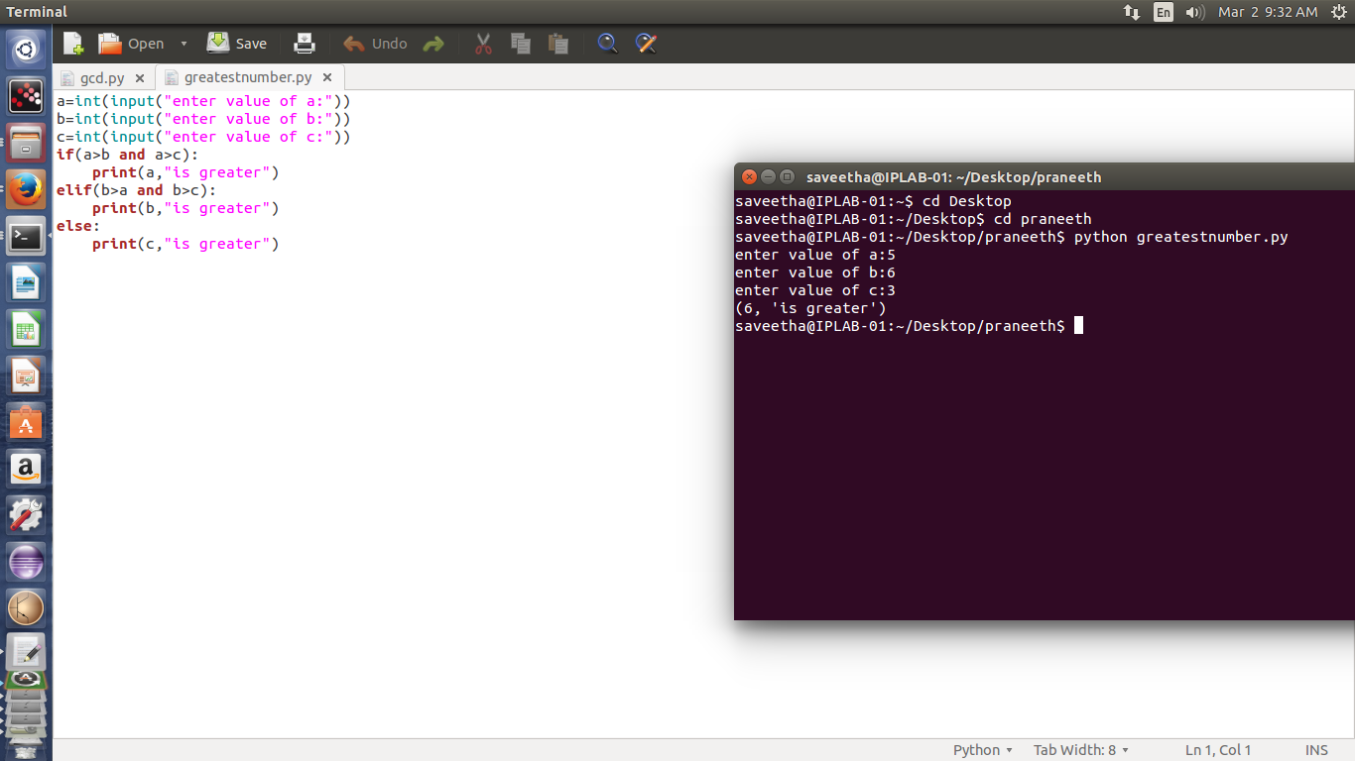

SOURCE CODE:

a=int(input("enter value of a:"))

b=int(input("enter value of b:"))

c=int(input("enter value of c:"))

if(a>b and a>c):

print(a,"is greater")

elif(b>a and b>c):

print(b,"is greater")

else:

print(c,"is greater")

OUTPUT:

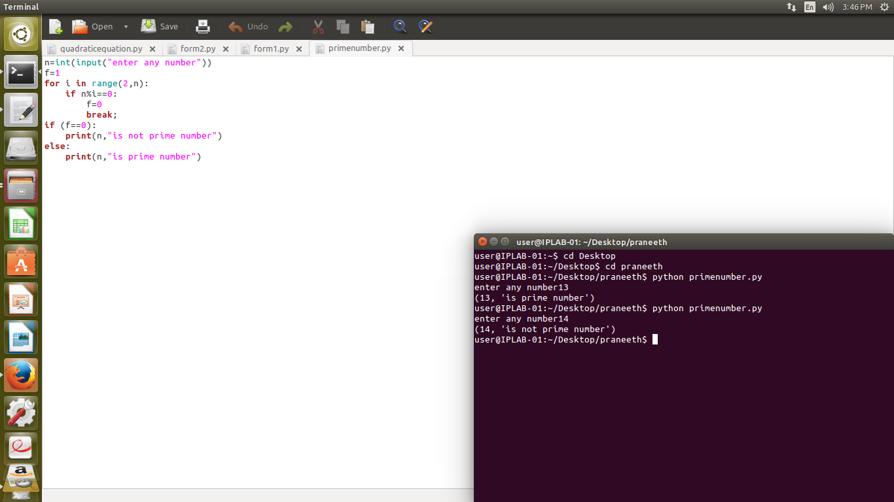

SOURCE CODE:

n=int(input("enter any number"))

f=1

for i in range(2,n):

if n%i==0:

f=0

break;

if (f==0):

print(n,"is not prime number")

else:

print(n,"is prime number")

OUTPUT:

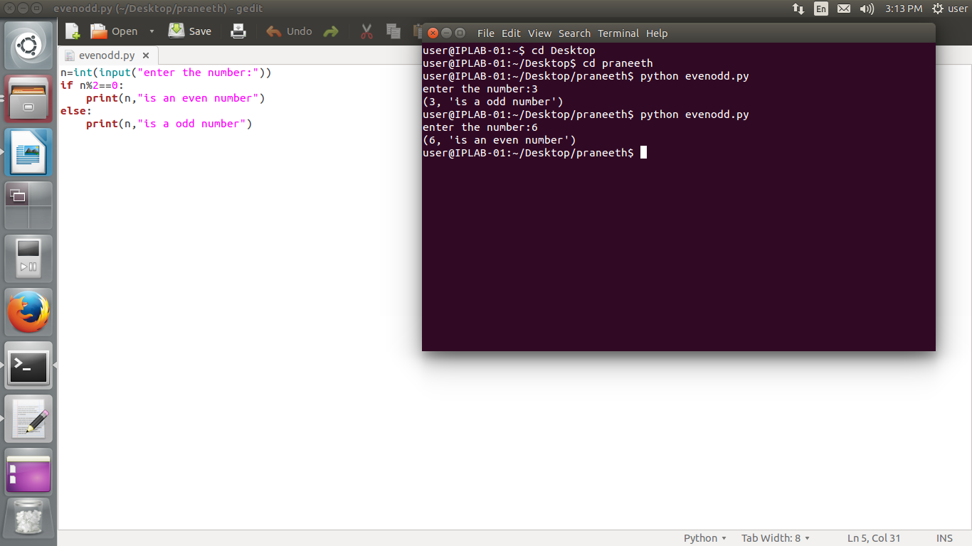

SOURCE CODE:

n=int(input("enter the number:"))

if n%2==0:

print(n,"is an even number")

else:

print(n,"is a odd number")

OUTPUT:

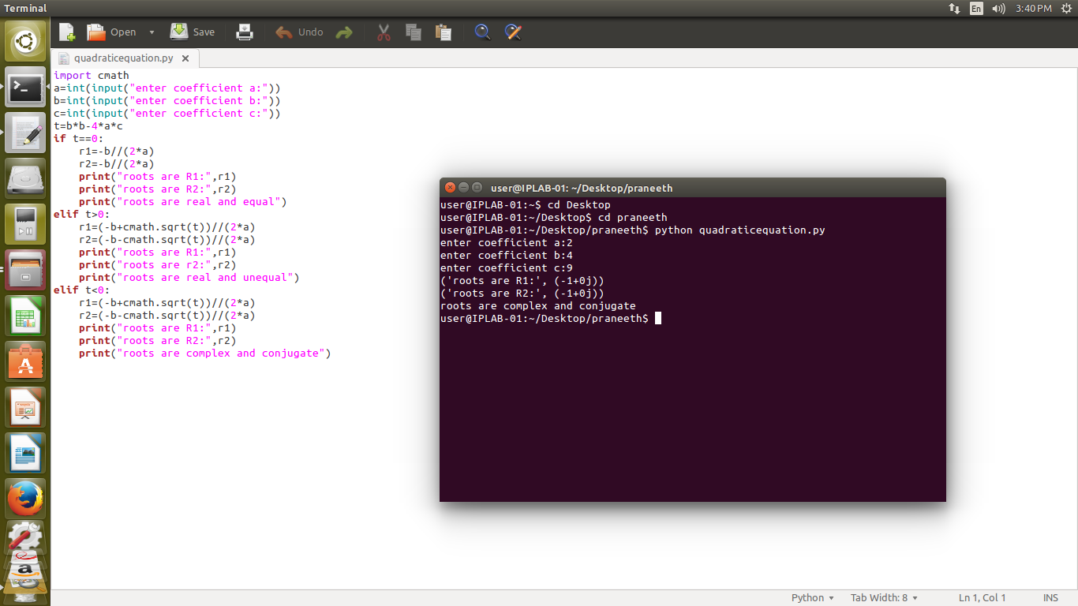

SOURCE CODE:

import cmath

a=int(input("enter coefficient a:"))

b=int(input("enter coefficient b:"))

c=int(input("enter coefficient c:"))

t=b*b-4*a*c

if t==0:

r1=-b//(2*a)

r2=-b//(2*a)

print("roots are R1:",r1)

print("roots are R2:",r2)

print("roots are real and equal")

elif t>0:

r1=(-b+cmath.sqrt(t))//(2*a)

r2=(-b-cmath.sqrt(t))//(2*a)

print("roots are R1:",r1)

print("roots are r2:",r2)

print("roots are real and unequal")

elif t<0:

r1=(-b+cmath.sqrt(t))//(2*a)

r2=(-b-cmath.sqrt(t))//(2*a)

print("roots are R1:",r1)

print("roots are R2:",r2)

print("roots are complex and conjugate")

OUTPUT:

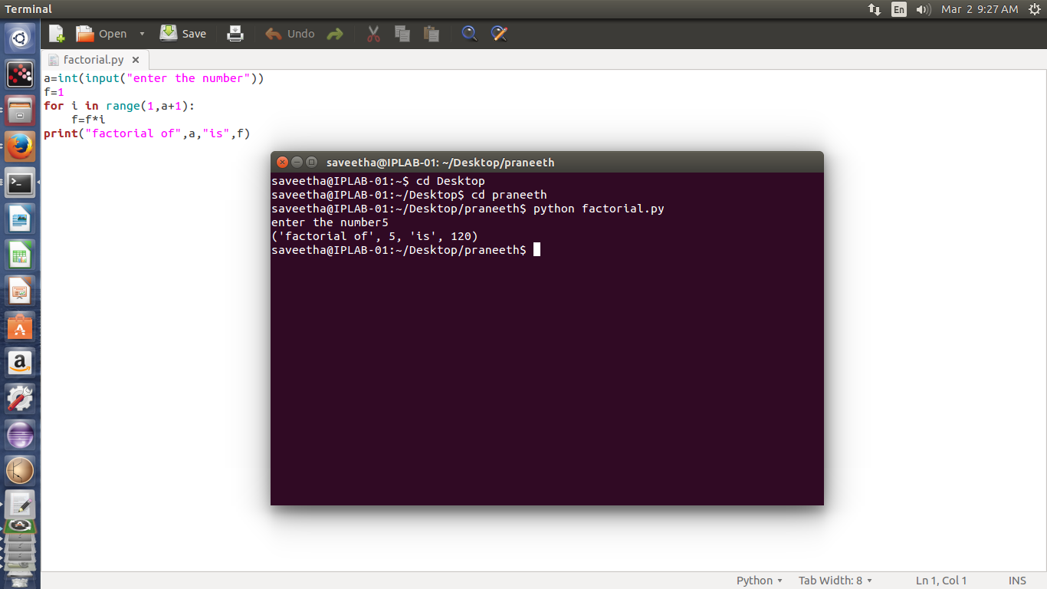

SOURCE CODE:

a=int(input("enter the number"))

f=1

for i in range(1,a+1):

f=f*i

print("factorial of",a,"is",f)

OUTPUT:

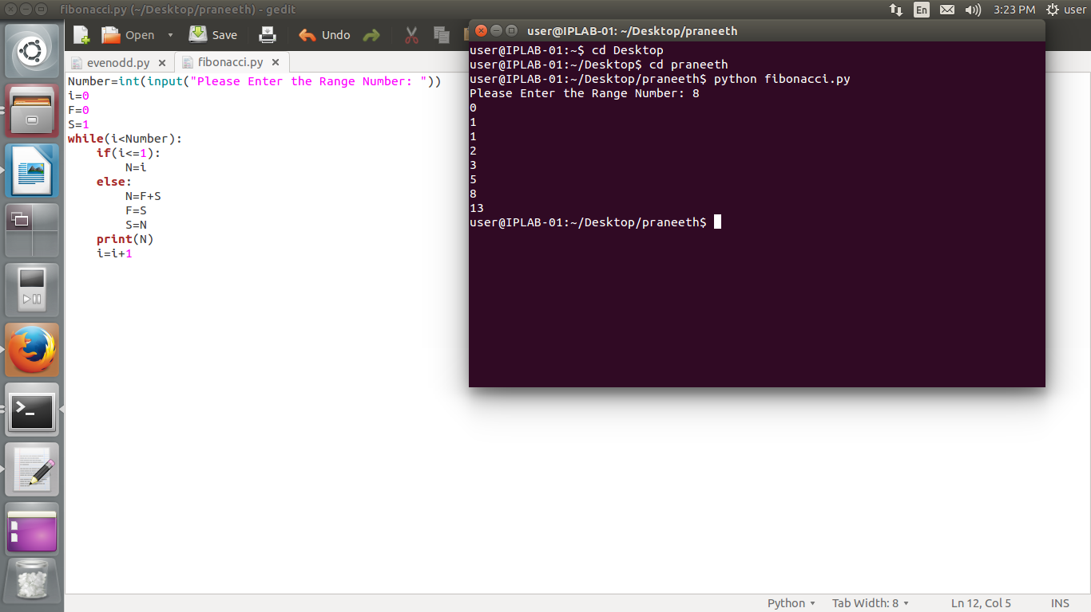

SOURCE CODE:

Number=int(input("Please Enter the Range Number: "))

i=0

F=0

S=1

while(i<Number):

if(i<=1):

N=i

else:

N=F+S

F=S

S=N

print(N)

i=i+1

OUTPUT:

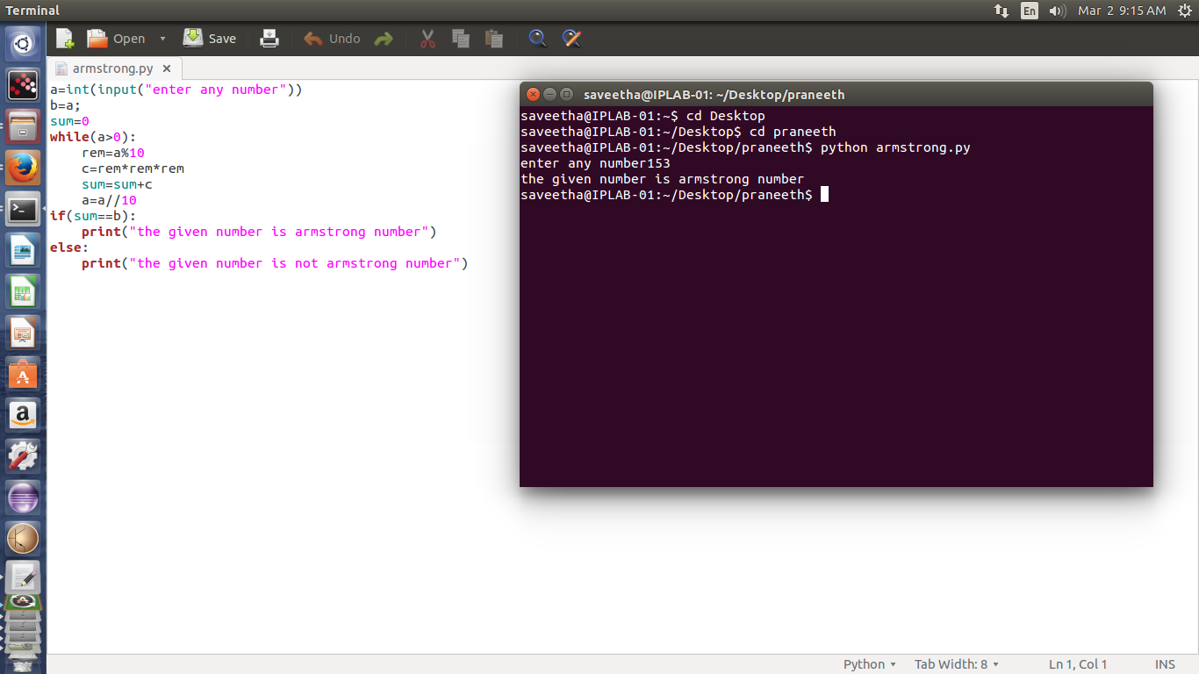

SOURCE CODE:

a=int(input("enter any number"))

b=a;

sum=0

while(a>0):

rem=a%10

c=rem*rem*rem

sum=sum+c

a=a//10

if(sum==b):

print("the given number is armstrong number")

else:

print("the given number is not armstrong number")

OUTPUT:

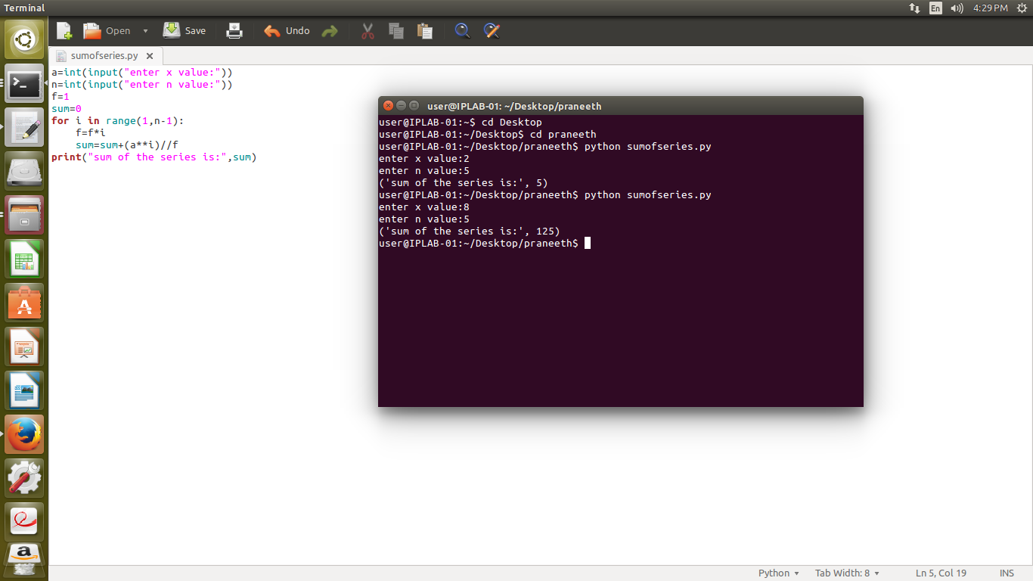

SOURCE CODE:

a=int(input("enter x value:"))

n=int(input("enter n value:"))

f=1

sum=0

for i in range(1,n-1):

f=f*i

sum=sum+(a**i)//f

print("sum of the series is:",sum)

OUTPUT:

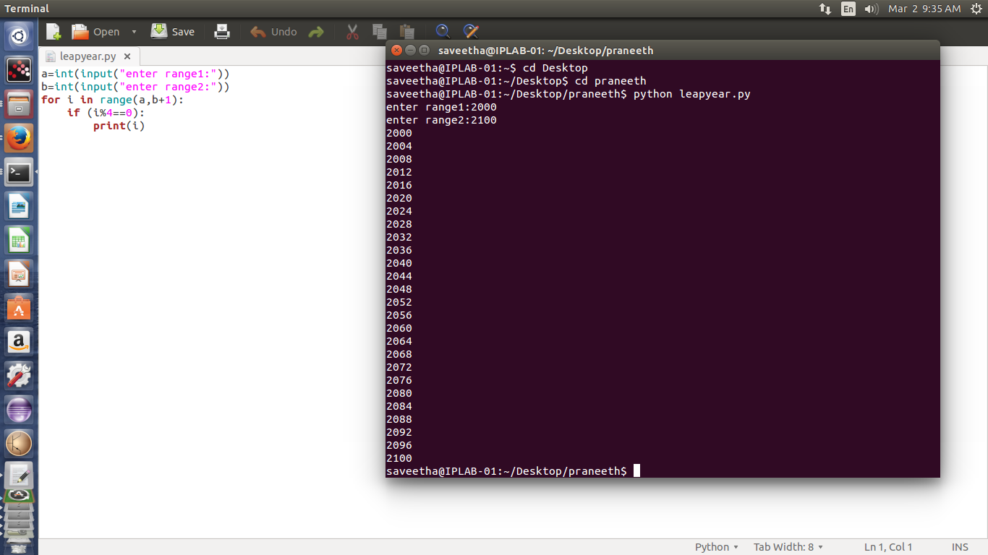

SOURCE CODE:

a=int(input("enter range1:"))

b=int(input("enter range2:"))

for i in range(a,b+1):

if (i%4==0):

print(i)

OUTPUT:

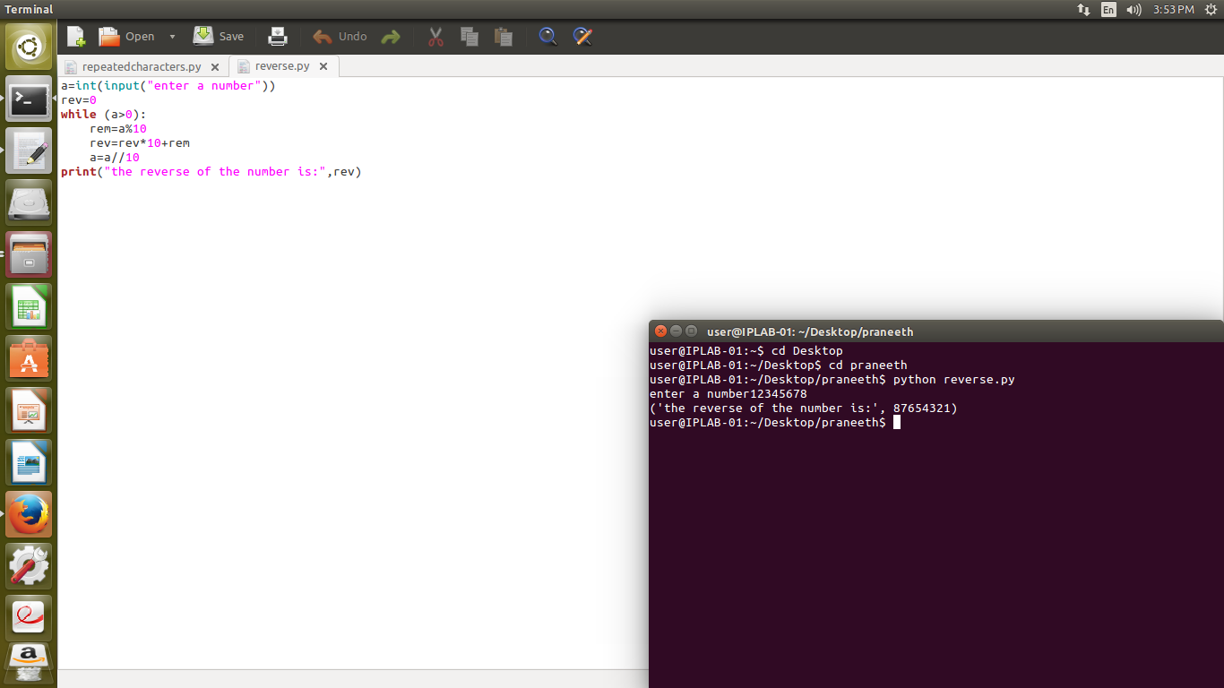

SOURCE CODE:

a=int(input("enter a number"))

rev=0

while (a>0):

rem=a%10

rev=rev*10+rem

a=a//10

print("the reverse of the number is:",rev)

OUTPUT:

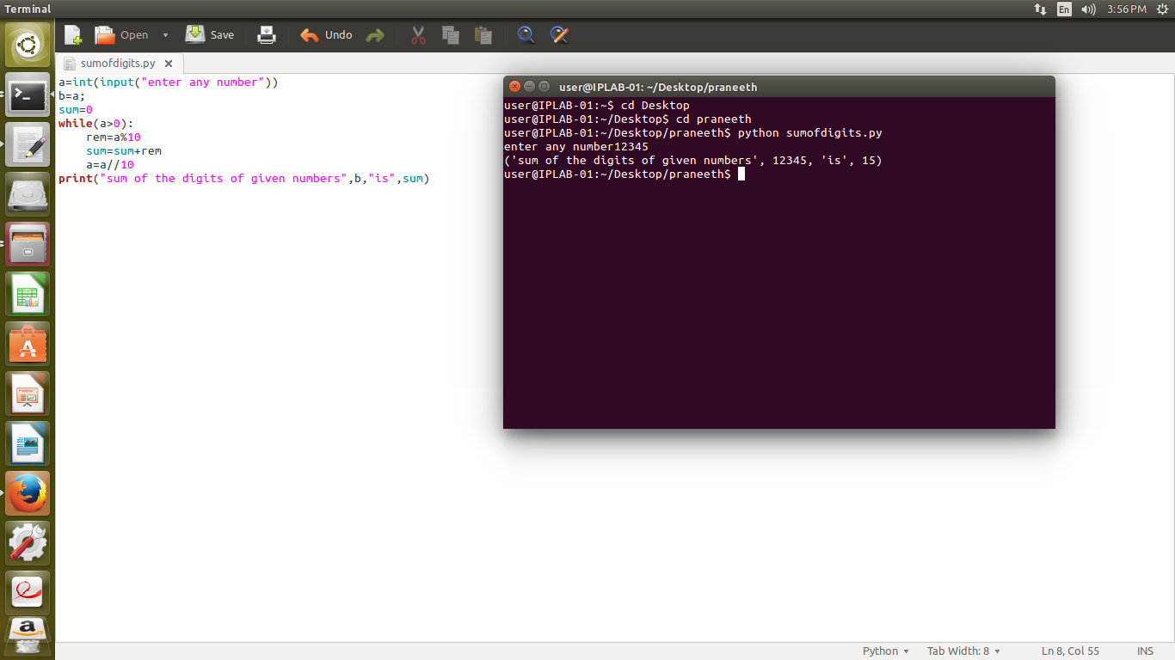

SOURCE CODE:

a=int(input("enter any number"))

b=a;

sum=0

while(a>0):

rem=a%10

sum=sum+rem

a=a//10

print("sum of the digits of given numbers",b,"is",sum)

OUTPUT:

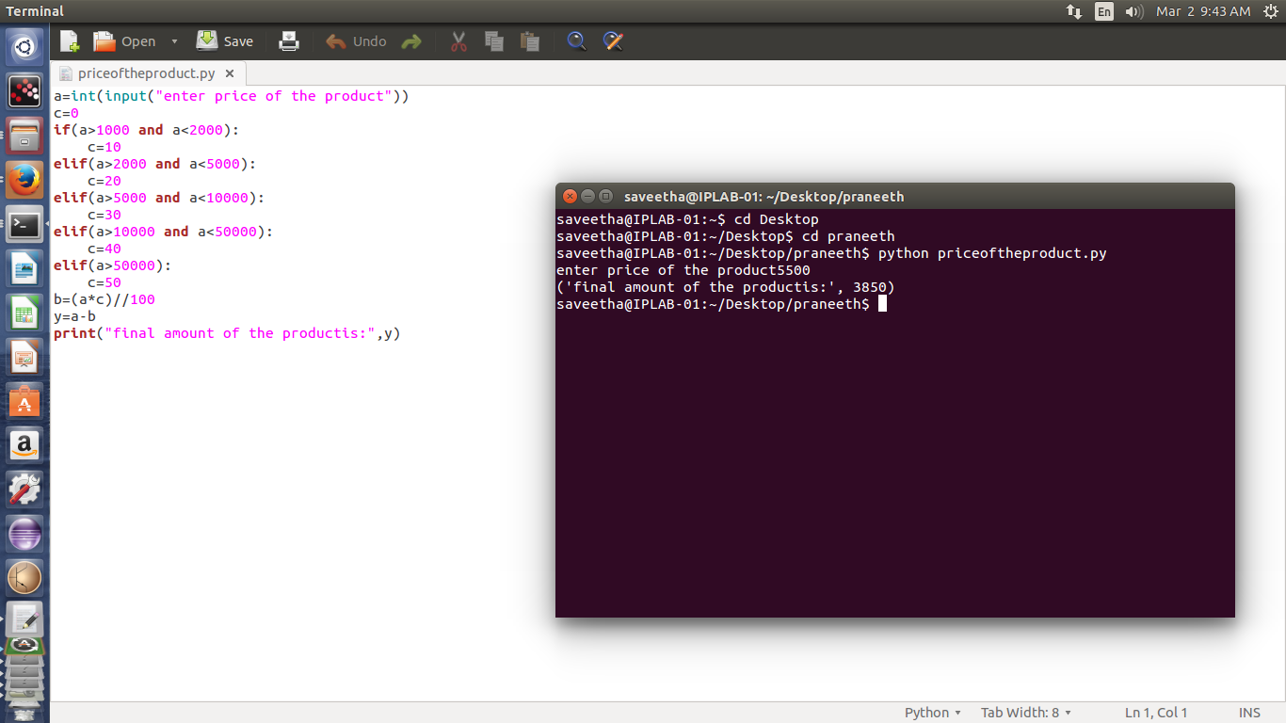

SOURCE CODE:

a=int(input("enter price of the product"))

c=0

if(a>1000 and a<2000):

c=10

elif(a>2000 and a<5000):

c=20

elif(a>5000 and a<10000):

c=30

elif(a>10000 and a<50000):

c=40

elif(a>50000):

c=50

b=(a*c)//100

y=a-b

print("final amount of the productis:",y)

OUTPUT:

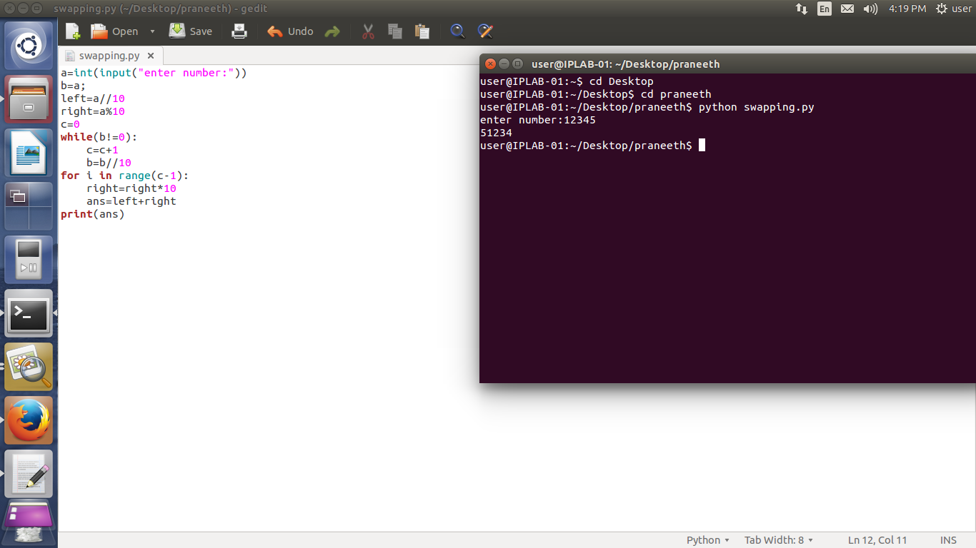

SOURCE CODE:

a=int(input("enter number:"))

b=a;

left=a//10

right=a%10

c=0

while(b!=0):

c=c+1

b=b//10

for i in range(c-1):

right=right*10

ans=left+right

print(ans)

OUTPUT:

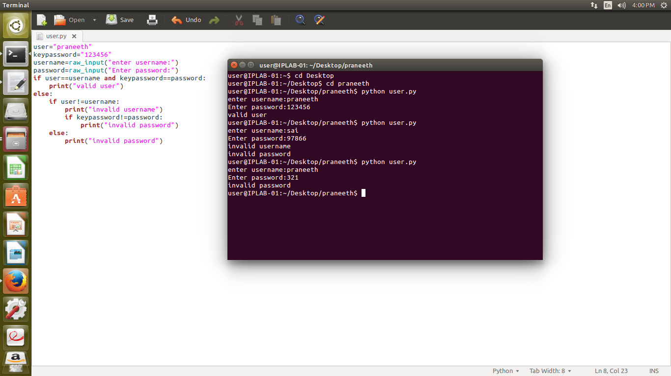

SOURCE CODE:

user="praneeth"

keypassword="123456"

username=raw_input("enter username:")

password=raw_input("Enter password:")

if user==username and keypassword==password:

print("valid user")

else:

if user!=username:

print("invalid username")

if keypassword!=password:

print("invalid password")

else:

print("invalid password")

OUTPUT:

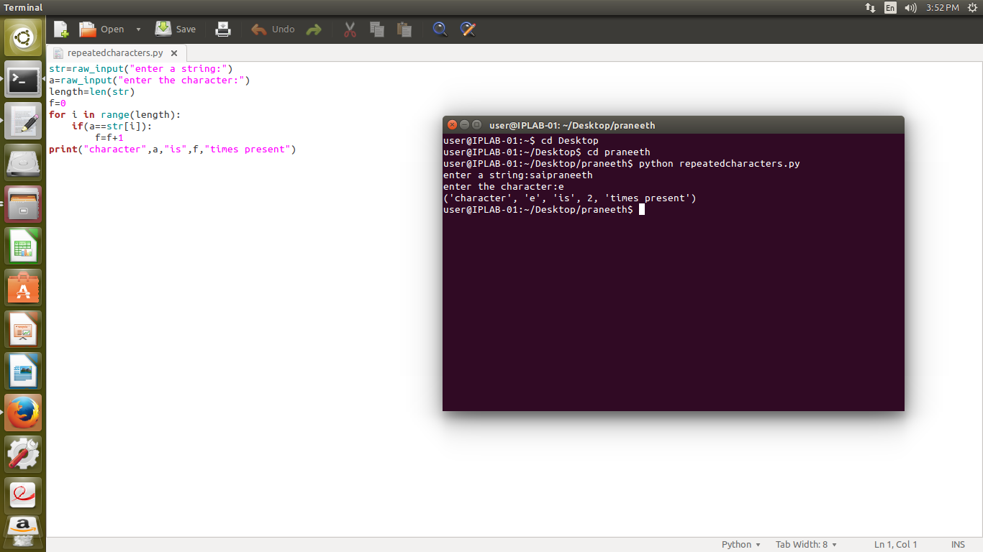

SOURCE CODE:

str=raw_input("enter a string:")

a=raw_input("enter the character:")

length=len(str)

f=0

for i in range(length):

if(a==str[i]):

f=f+1

print("character",a,"is",f,"times present")

OUTPUT:

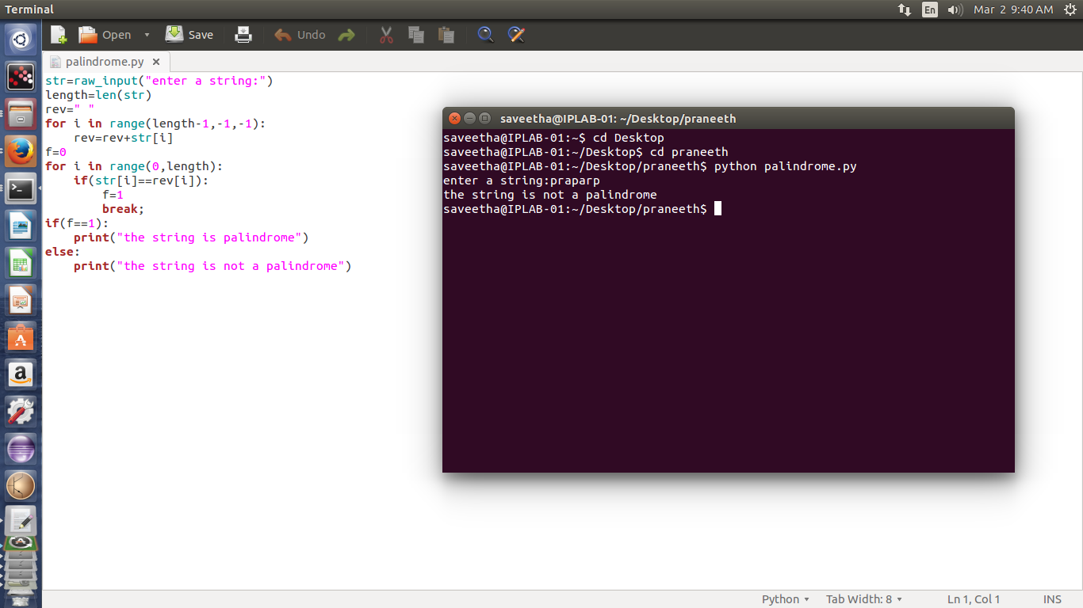

SOURCE CODE:

str=raw_input("enter a string:")

length=len(str)

rev=" "

for i in range(length-1,-1,-1):

rev=rev+str[i]

f=0

for i in range(0,length):

if(str[i]==rev[i]):

f=1

break;

if(f==1):

print("the string is palindrome")

else:

print("the string is not a palindrome")

OUTPUT:

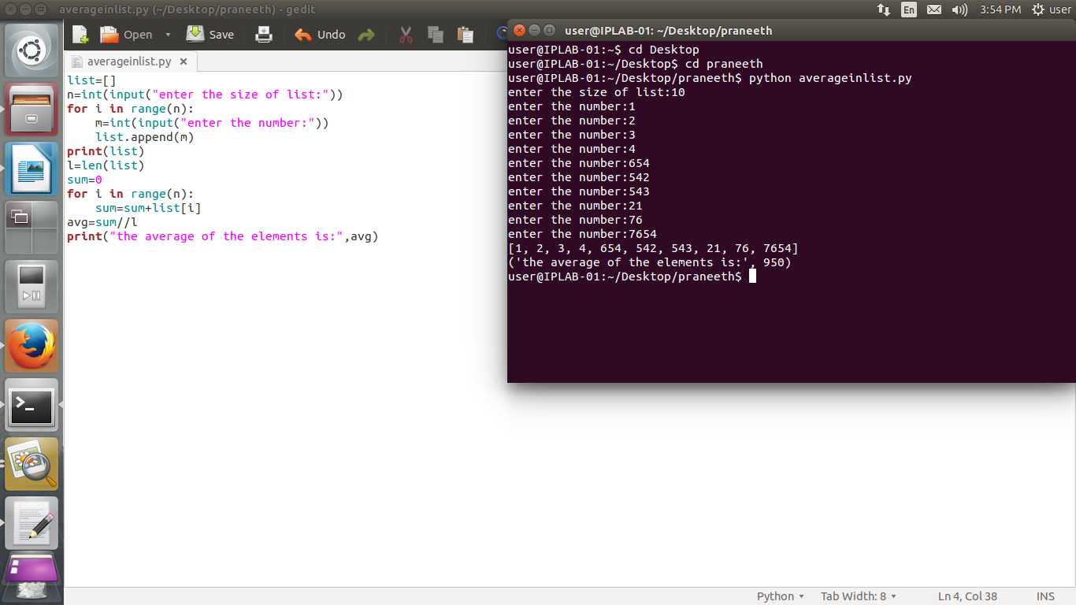

SOURCE CODE:

list=[]

n=int(input("enter the size of list:"))

for i in range(n):

m=int(input("enter the number:"))

list.append(m)

print(list)

l=len(list)

sum=0

for i in range(n):

sum=sum+list[i]

avg=sum//l

print("the average of the elements is:",avg)

OUTPUT:

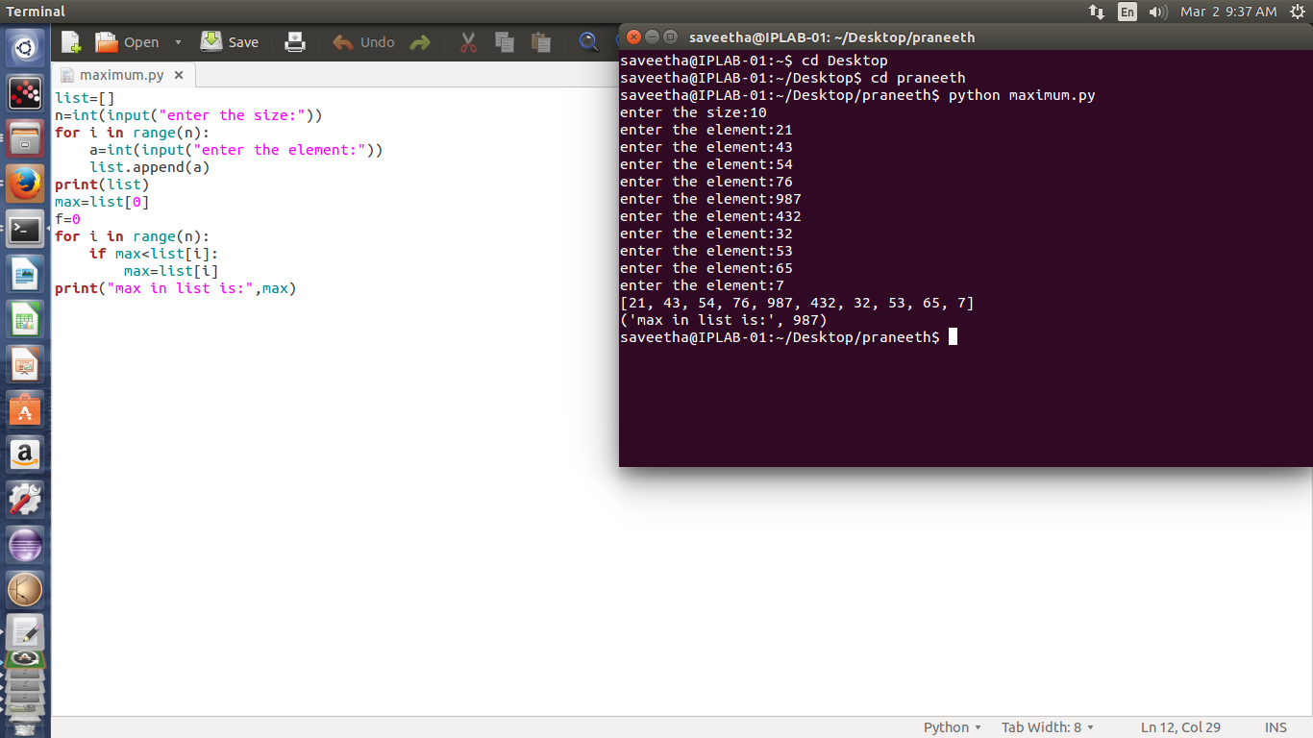

SOURCE CODE:

list=[]

n=int(input("enter the size:"))

for i in range(n):

a=int(input("enter the element:"))

list.append(a)

print(list)

max=list[0]

f=0

for i in range(n):

if max<list[i]:

max=list[i]

print("max in list is:",max)

OUTPUT:

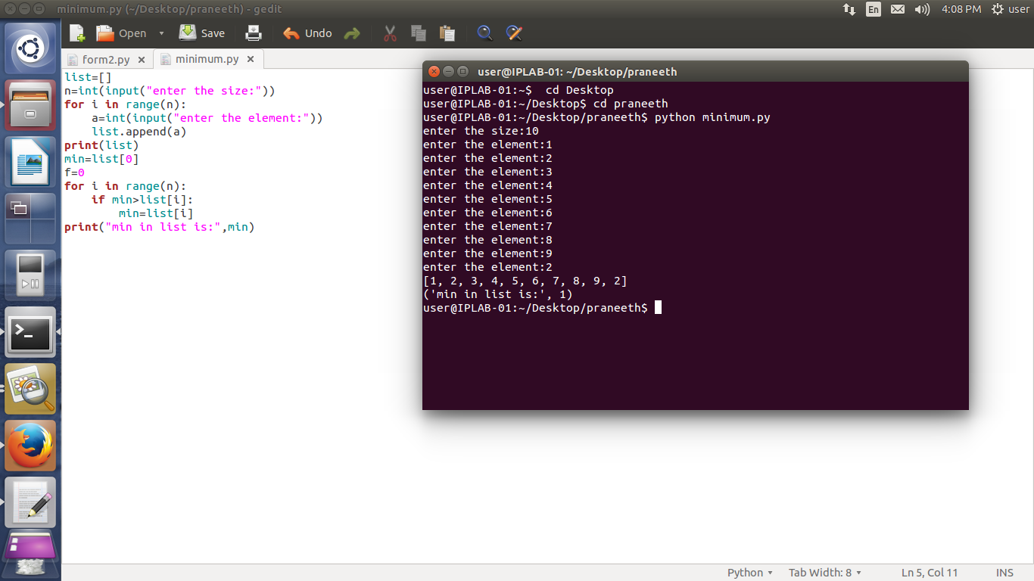

SOURCE CODE:

list=[]

n=int(input("enter the size:"))

for i in range(n):

a=int(input("enter the element:"))

list.append(a)

print(list)

min=list[0]

f=0

for i in range(n):

if min>list[i]:

min=list[i]

print("min in list is:",min)

OUTPUT:

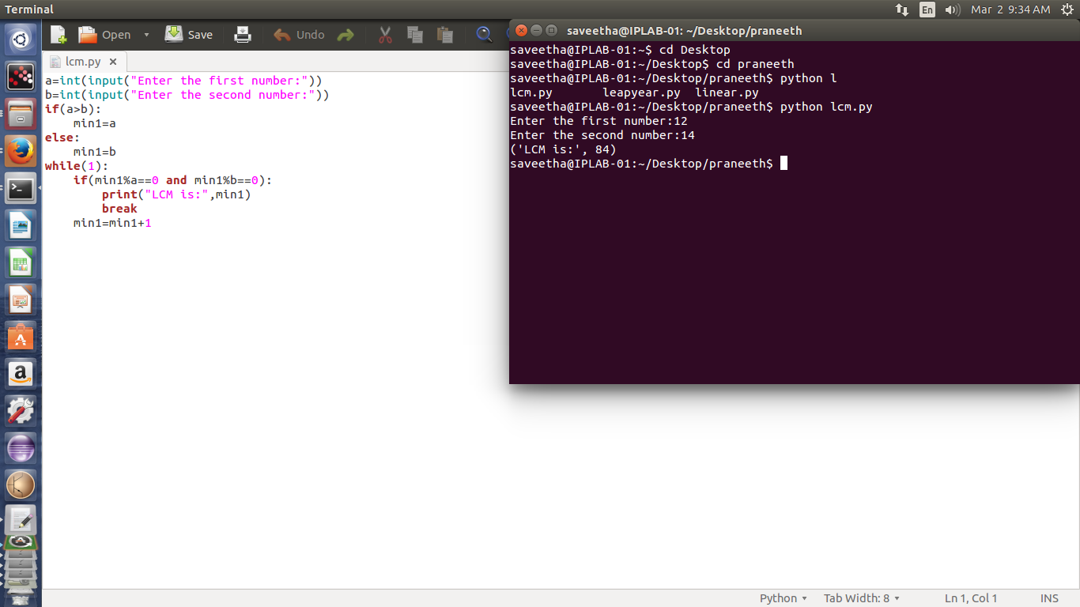

SOURCE CODE:

a=int(input("Enter the first number:"))

b=int(input("Enter the second number:"))

if(a>b):

min1=a

else:

min1=b

while(1):

if(min1%a==0 and min1%b==0):

print("LCM is:",min1)

break

min1=min1+1

OUTPUT:

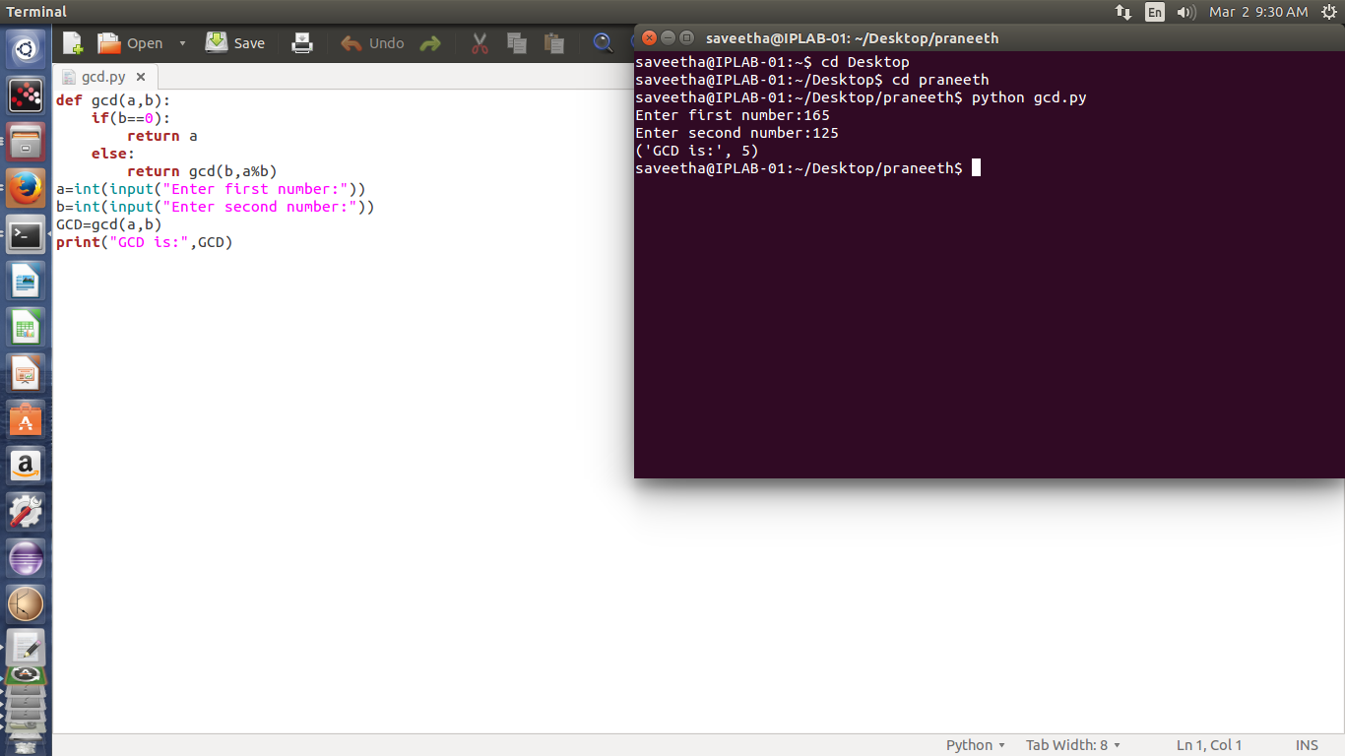

SOURCE CODE:

def gcd(a,b):

if(b==0):

return a

else:

return gcd(b,a%b)

a=int(input("Enter first number:"))

b=int(input("Enter second number:"))

GCD=gcd(a,b)

print("GCD is:",GCD)

OUTPUT:

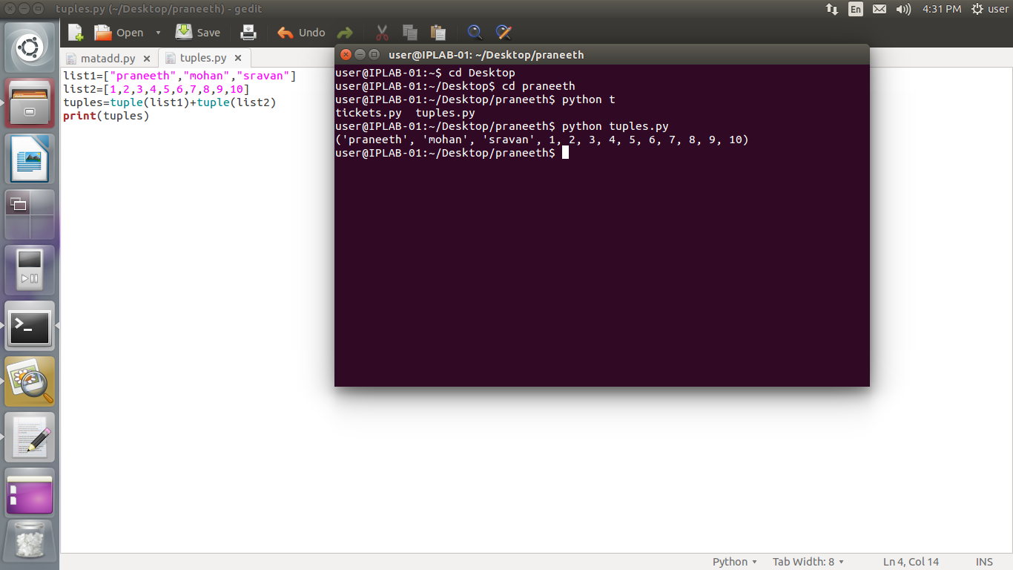

SOURCE CODE:

list1=["praneeth","mohan","sravan"]

list2=[1,2,3,4,5,6,7,8,9,10]

tuples=tuple(list1)+tuple(list2)

print(tuples)

OUTPUT:

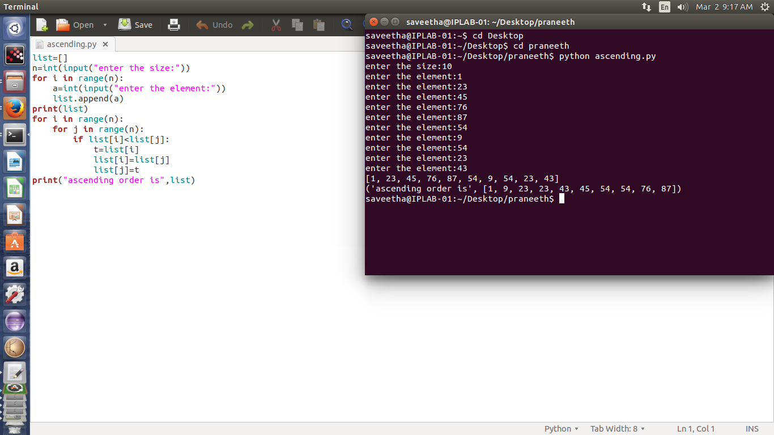

SOURCE CODE:

list=[]

n=int(input("enter the size:"))

for i in range(n):

a=int(input("enter the element:"))

list.append(a)

print(list)

for i in range(n):

for j in range(n):

if list[i]<list[j]:

t=list[i]

list[i]=list[j]

list[j]=t

print("ascending order is",list)

OUTPUT:

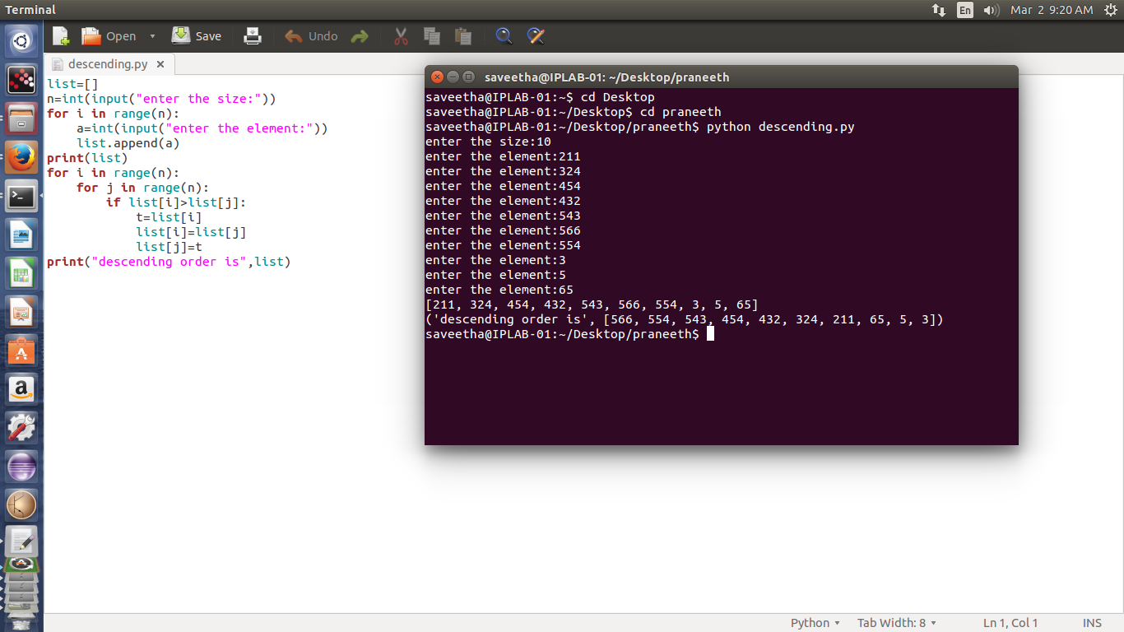

SOURCE CODE:

list=[]

n=int(input("enter the size:"))

for i in range(n):

a=int(input("enter the element:"))

list.append(a)

print(list)

for i in range(n):

for j in range(n):

if list[i]>list[j]:

t=list[i]

list[i]=list[j]

list[j]=t

print("descending order is",list)

OUTPUT:

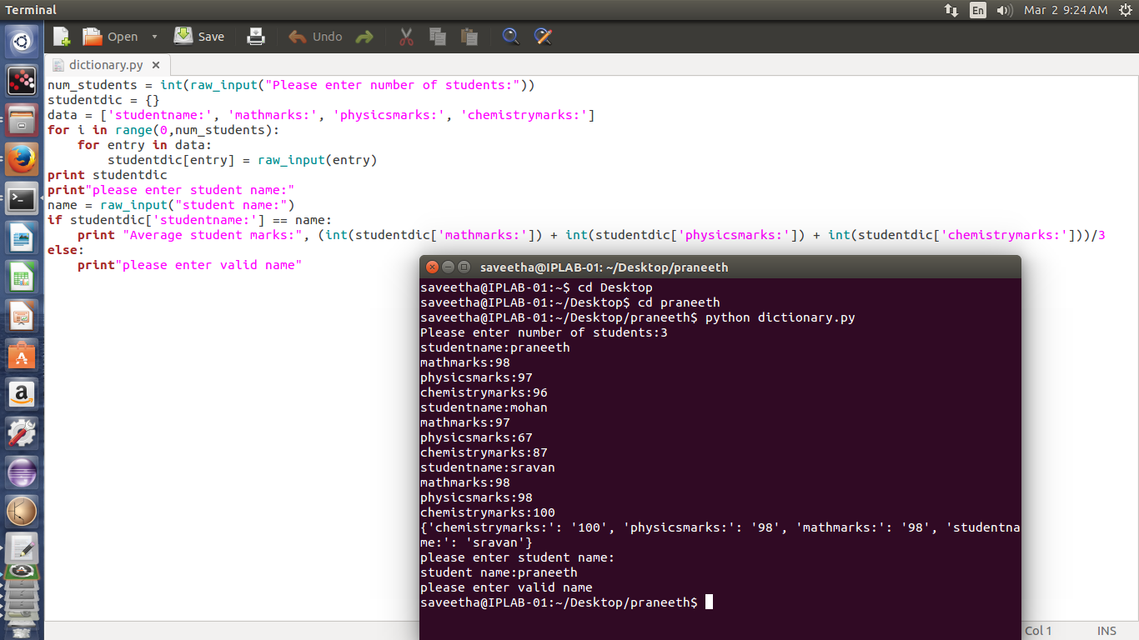

SOURCE CODE:

num_students = int(raw_input("Please enter number of students:"))

studentdic = {}

data = ['studentname:', 'mathmarks:', 'physicsmarks:', 'chemistrymarks:']

for i in range(0,num_students):

for entry in data:

studentdic[entry] = raw_input(entry)

print studentdic

print"please enter student name:"

name = raw_input("student name:")

if studentdic['studentname:'] == name:

print "Average student marks:", (int(studentdic['mathmarks:']) + int(studentdic['physicsmarks:']) + int(studentdic['chemistrymarks:']))/3

else:

print"please enter valid name"

OUTPUT:

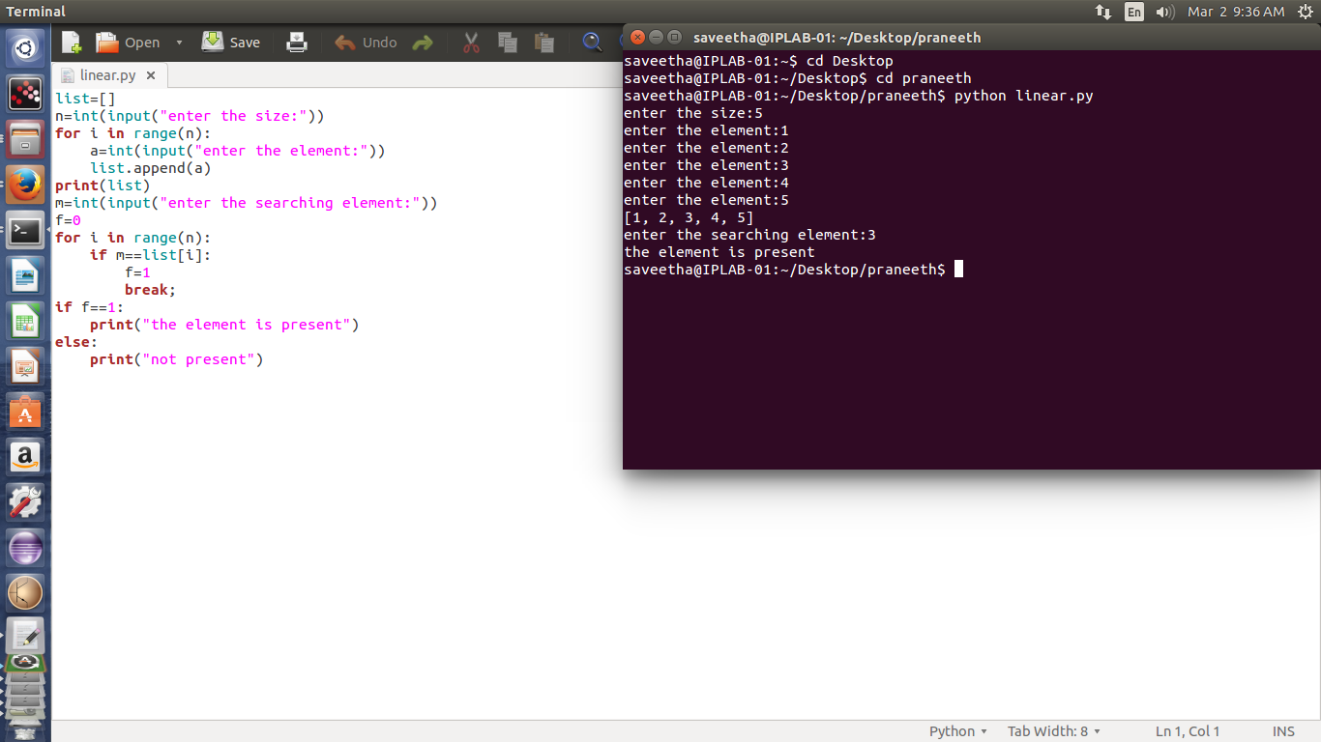

SOURCE CODE:

list=[]

n=int(input("enter the size:"))

for i in range(n):

a=int(input("enter the element:"))

list.append(a)

print(list)

m=int(input("enter the searching element:"))

f=0

for i in range(n):

if m==list[i]:

f=1

break;

if f==1:

print("the element is present")

else:

print("not present")

OUTPUT:

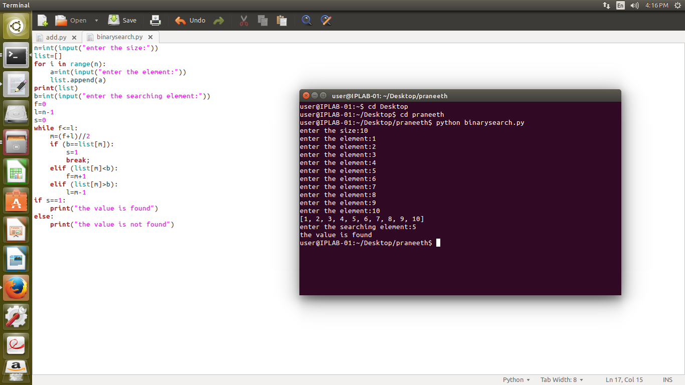

SOURCE CODE:

n=int(input("enter the size:"))

list=[]

for i in range(n):

a=int(input("enter the element:"))

list.append(a)

print(list)

b=int(input("enter the searching element:"))

f=0

l=n-1

s=0

while f<=l:

m=(f+l)//2

if (b==list[m]):

s=1

break;

elif (list[m]<b):

f=m+1

elif (list[m]>b):

l=m-1

if s==1:

print("the value is found")

else:

print("the value is not found")

OUTPUT:

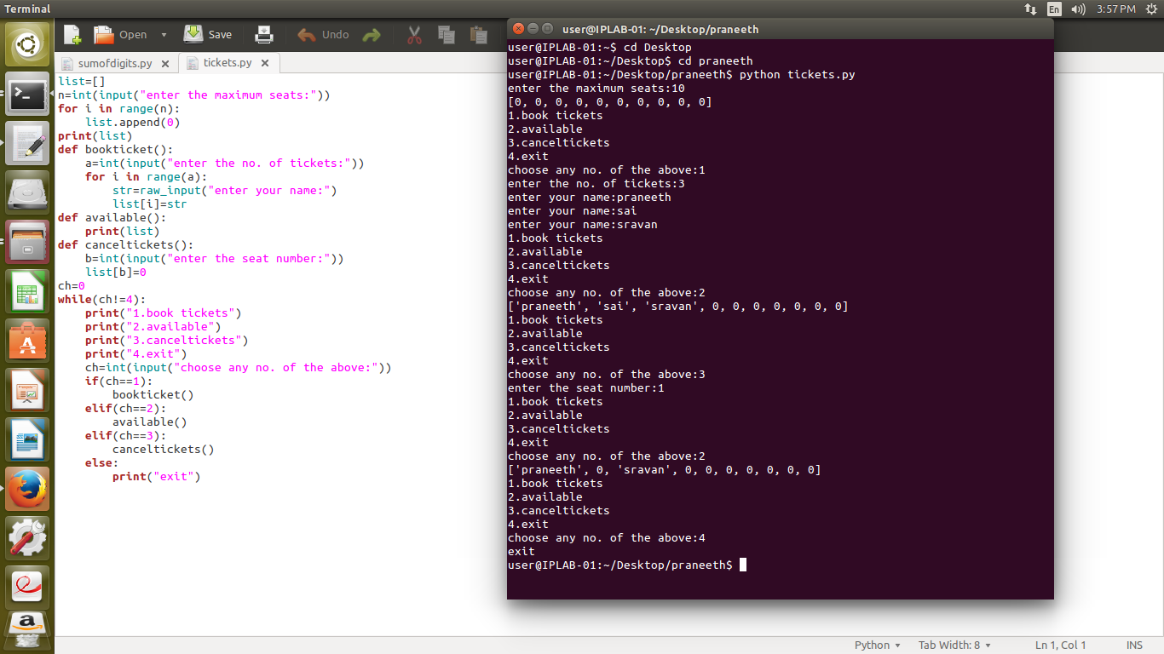

SOURCE CODE:

list=[]

n=int(input("enter the maximum seats:"))  
for i in range(n):  
 list.append(0)  
print(list)

def bookticket():  
 a=int(input("enter the no. of tickets:"))  
 for i in range(a):  
 str=raw_input("enter your name:")  
 list[i]=str

def available():  
 print(list)

def canceltickets():  
 b=int(input("enter the seat number:"))  
 list[b]=0  
ch=0  
while(ch!=4):  
 print("1.book tickets")  
 print("2.available")  
 print("3.canceltickets")  
 print("4.exit")  
 ch=int(input("choose any no. of the above:"))  
 if(ch==1):  
 bookticket()  
 elif(ch==2):  
 available()  
 elif(ch==3):  
 canceltickets()  
 else:  
 print("exit")

OUTPUT:

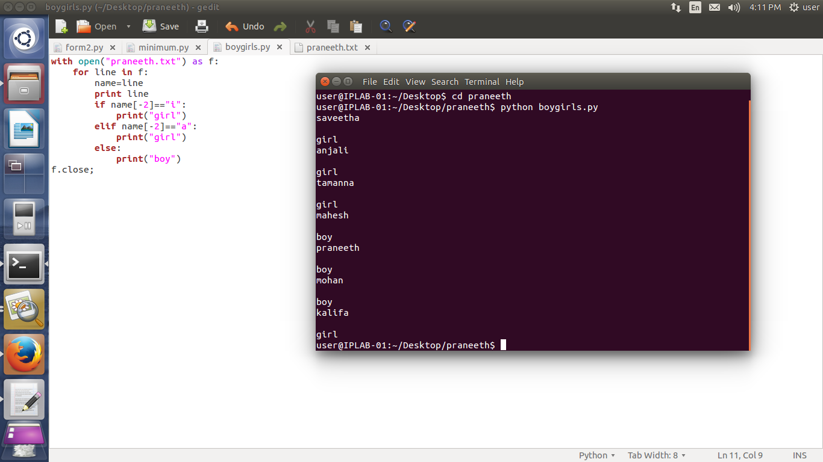

SOURCE CODE:

with open("praneeth.txt") as f:

for line in f:

name=line

print line

if name[-2]=="i":

print("girl")

elif name[-2]=="a":

print("girl")

else:

print("boy")

f.close;

OUTPUT:

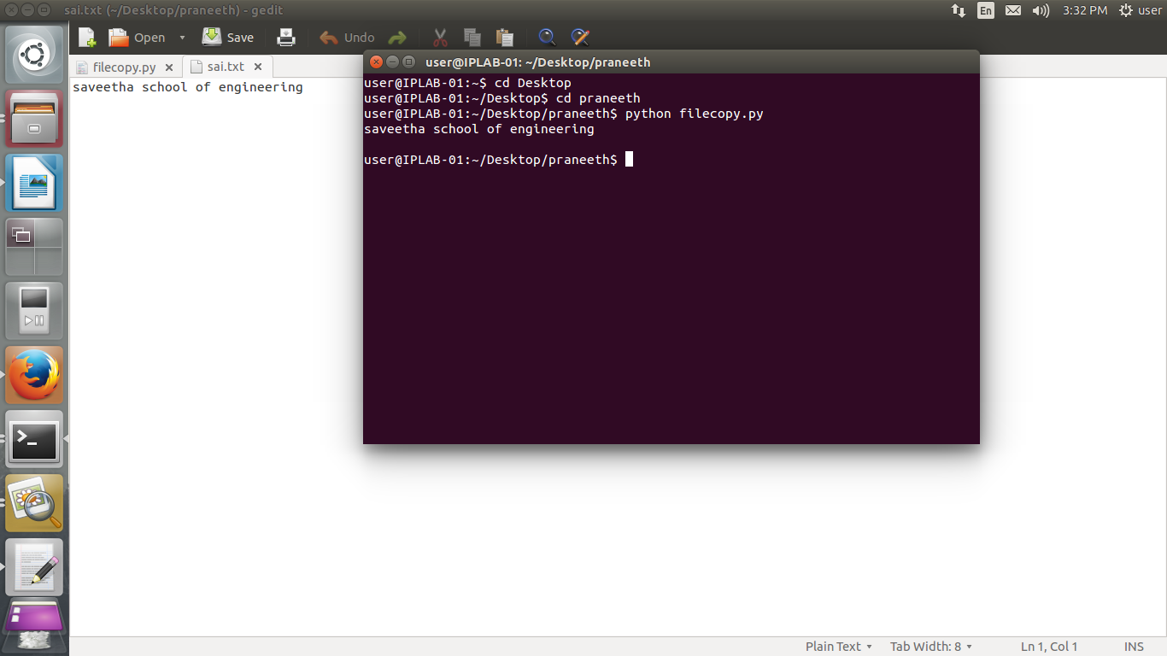

SOURCE CODE:

file=open("sai.txt","w")

with open("praneeth.txt") as f:

for line in f:

print(line)

file.write(line)

file.close;

OUTPUT:

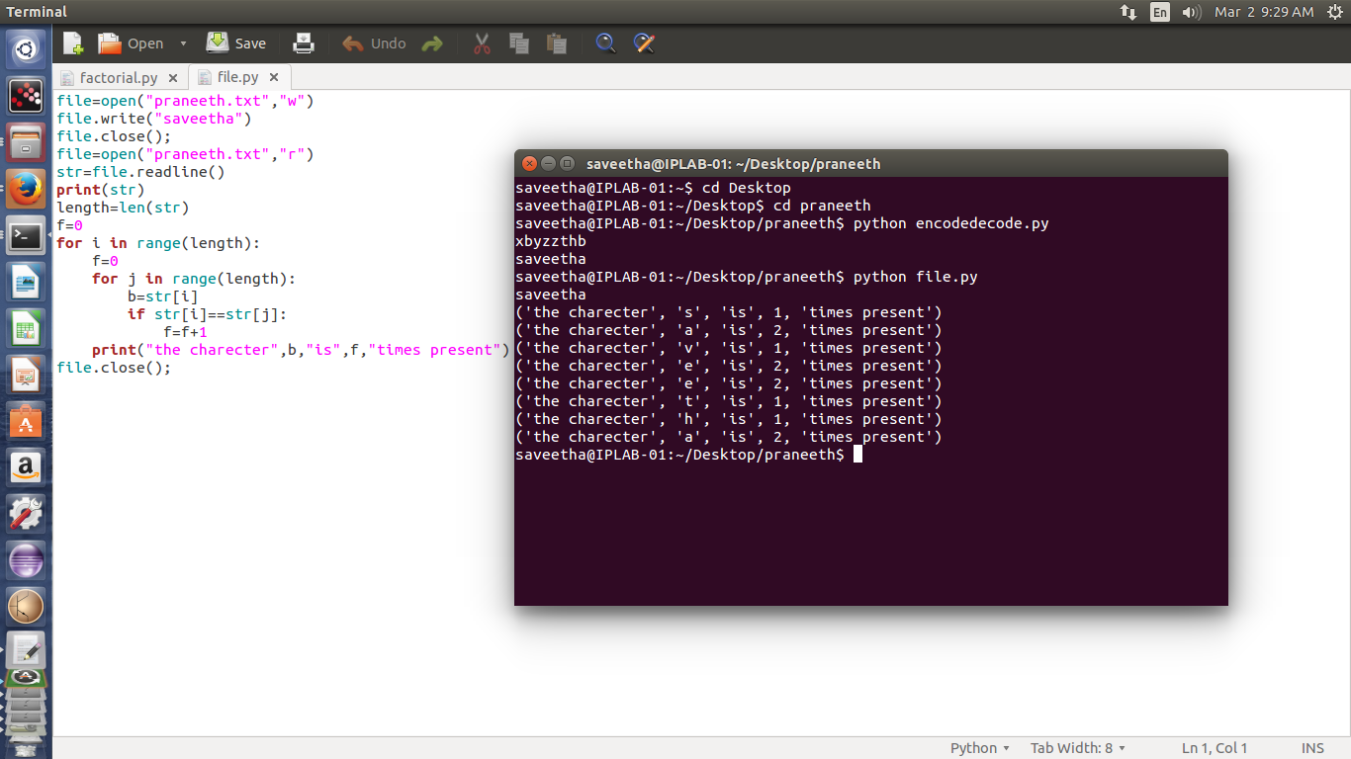

SOURCE CODE:

file=open("praneeth.txt","w")

file.write("saveetha")

file.close();

file=open("praneeth.txt","r")

str=file.readline()

print(str)

length=len(str)

f=0

for i in range(length):

f=0

for j in range(length):

b=str[i]

if str[i]==str[j]:

f=f+1

print("the charecter",b,"is",f,"times present")

file.close();

OUTPUT:

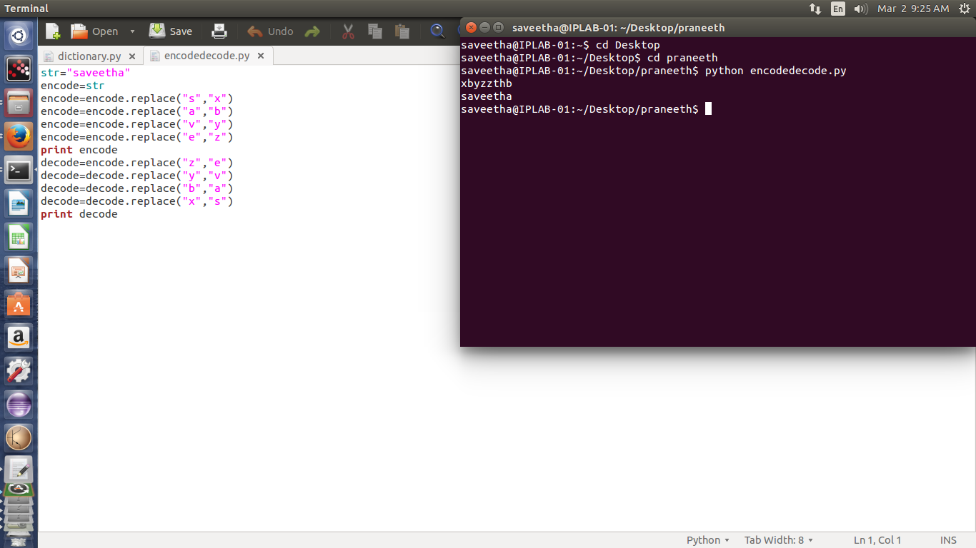

SOURCE CODE:

str="saveetha"

encode=str

encode=encode.replace("s","x")

encode=encode.replace("a","b")

encode=encode.replace("v","y")

encode=encode.replace("e","z")

print encode

decode=encode.replace("z","e")

decode=decode.replace("y","v")

decode=decode.replace("b","a")

decode=decode.replace("x","s")

print decode

OUTPUT:

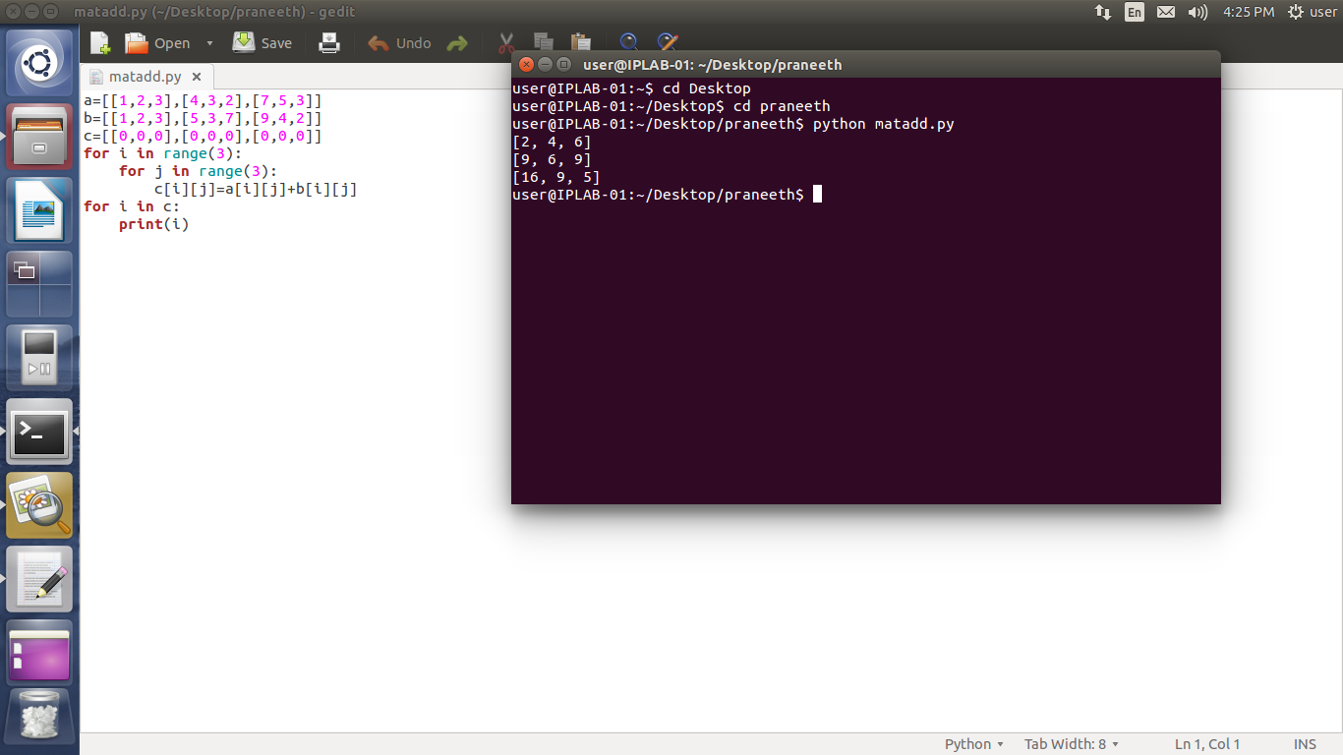

SOURCE CODE:

a=[[1,2,3],[4,3,2],[7,5,3]]

b=[[1,2,3],[5,3,7],[9,4,2]]

c=[[0,0,0],[0,0,0],[0,0,0]]

for i in range(3):

for j in range(3):

c[i][j]=a[i][j]+b[i][j]

for i in c:

print(i)

OUTPUT:

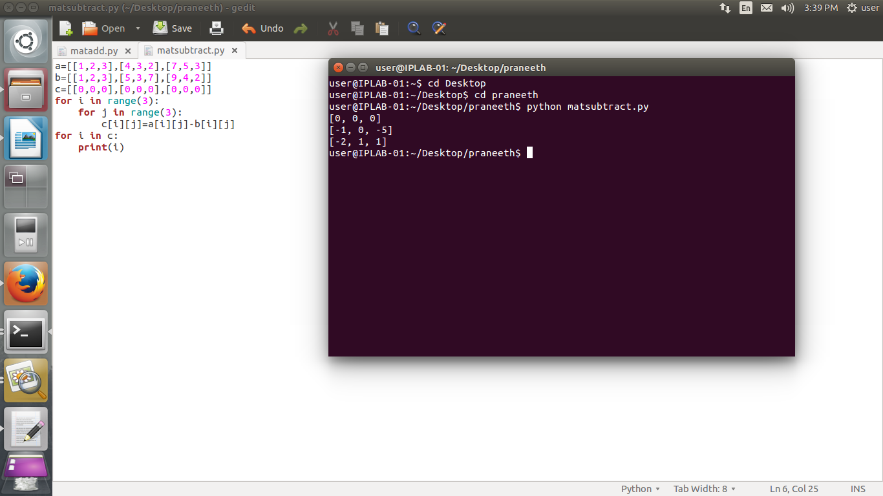

SOURCE CODE:

a=[[1,2,3],[4,3,2],[7,5,3]]

b=[[1,2,3],[5,3,7],[9,4,2]]

c=[[0,0,0],[0,0,0],[0,0,0]]

for i in range(3):

for j in range(3):

c[i][j]=a[i][j]-b[i][j]

for i in c:

print(i)

OUTPUT:

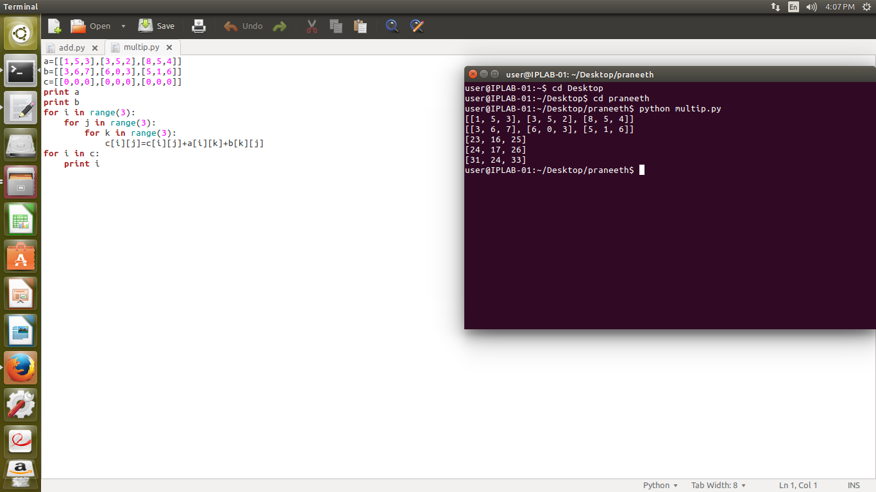

SOURCE CODE:

a=[[1,5,3],[3,5,2],[8,5,4]]

b=[[3,6,7],[6,0,3],[5,1,6]]

c=[[0,0,0],[0,0,0],[0,0,0]]

print a

print b

for i in range(3):

for j in range(3):

for k in range(3):

c[i][j]=c[i][j]+a[i][k]+b[k][j]

for i in c:

print i

OUTPUT:

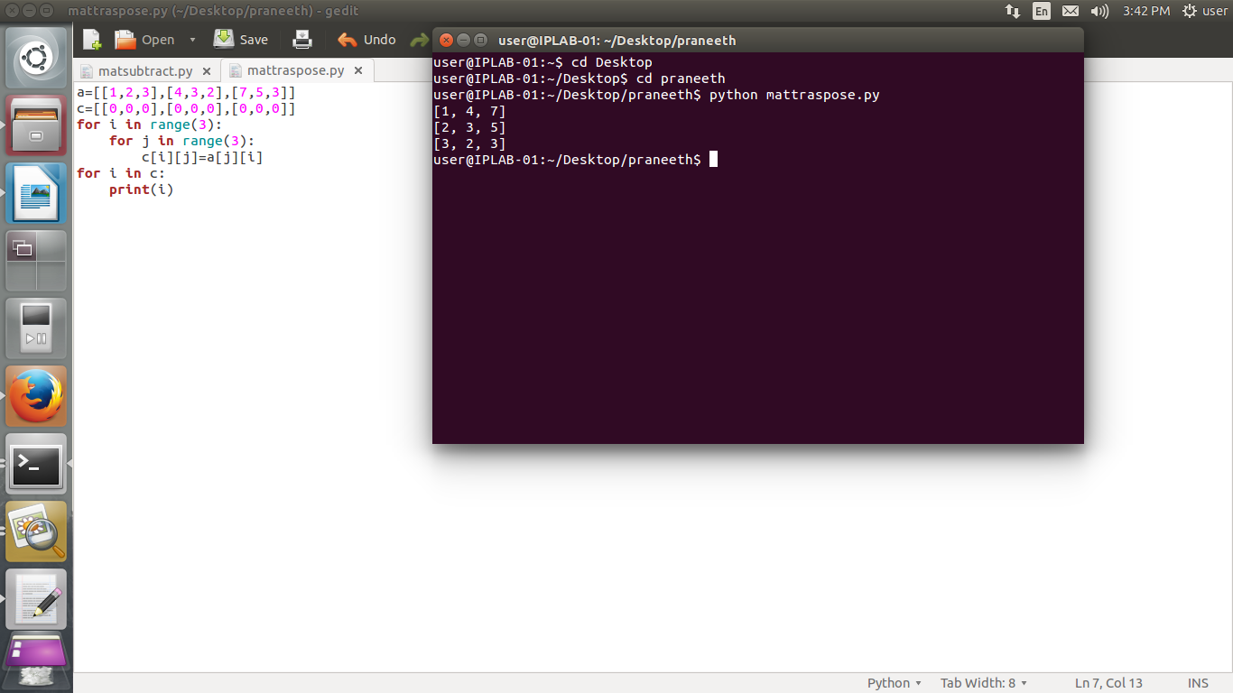

SOURCE CODE:

a=[[1,2,3],[4,3,2],[7,5,3]]

c=[[0,0,0],[0,0,0],[0,0,0]]

for i in range(3):

for j in range(3):

c[i][j]=a[j][i]

for i in c:

print(i)

OUTPUT:

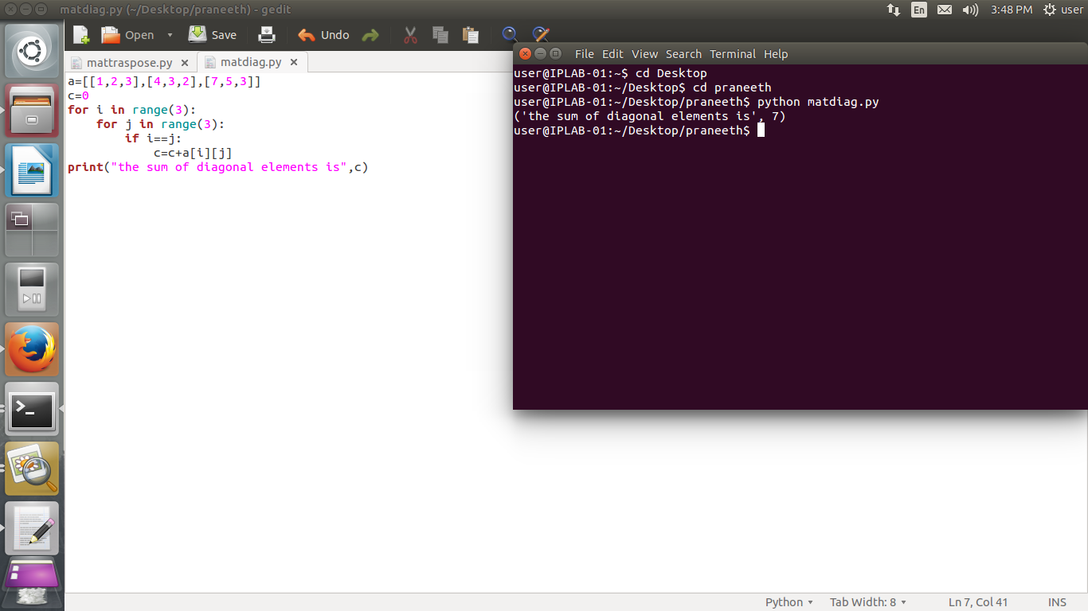

SOURCE CODE:

a=[[1,2,3],[4,3,2],[7,5,3]]

c=0

for i in range(3):

for j in range(3):

if i==j:

c=c+a[i][j]

print("the sum of diagonal elements is",c)

OUTPUT:

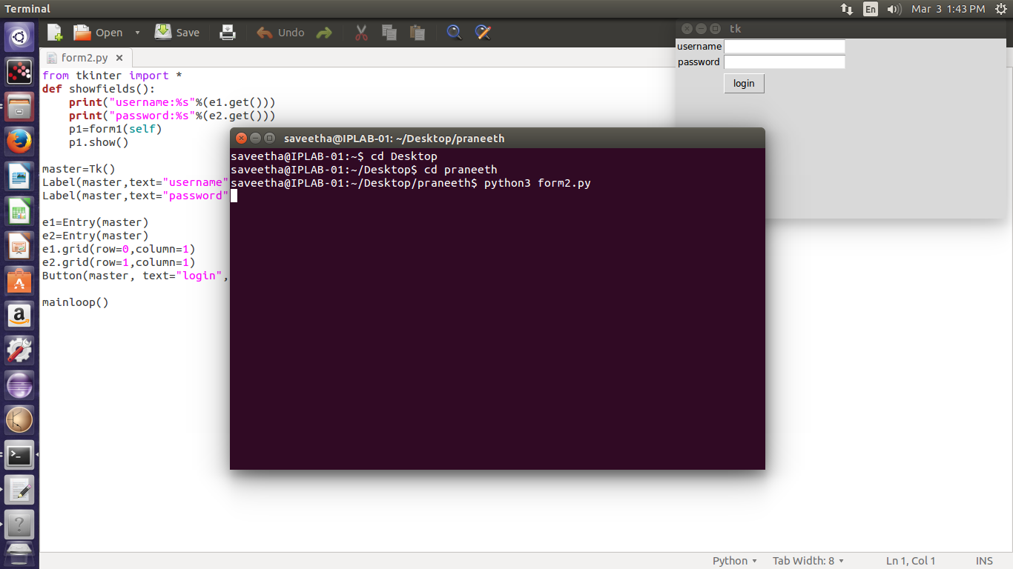

SOURCE CODE:

from tkinter import *

def showfields():

print("username:%s"%(e1.get()))

print("password:%s"%(e2.get()))

p1=form1(self)

p1.show()

master=Tk()

Label(master,text="username").grid(row=0)

Label(master,text="password").grid(row=1)

e1=Entry(master)

e2=Entry(master)

e1.grid(row=0,column=1)

e2.grid(row=1,column=1)

Button(master, text="login", command=showfields).grid(row=3, column=1, sticky=W, pady=4)

mainloop()

OUTPUT:

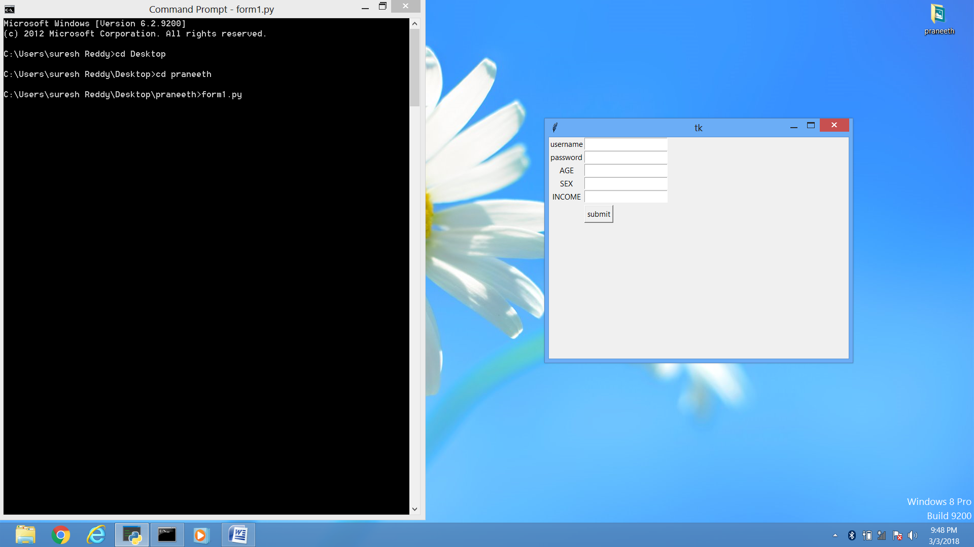

SOURCE CODE:

from tkinter import *

class form():

def showfields():

print("username:%s"%(e1.get()))  
 print("password:%s"%(e2.get()))  
 print("age:%s"%(e3.get()))  
 print("sex:%s"%(e4.get()))  
 print("income:%s"%(e5.get()))

master=Tk()

Label(master,text="username").grid(row=0)  
 Label(master,text="password").grid(row=1)  
 Label(master,text="AGE").grid(row=2)  
 Label(master,text="SEX").grid(row=3)  
 Label(master,text="INCOME").grid(row=4)

e1=Entry(master)  
 e2=Entry(master)  
 e3=Entry(master)  
 e4=Entry(master)  
 e5=Entry(master)

e1.grid(row=0,column=1)  
 e2.grid(row=1,column=1)  
 e3.grid(row=2,column=1)  
 e4.grid(row=3,column=1)  
 e5.grid(row=4,column=1)

Button(master, text="submit", command=showfields).grid(row=5, column=1, sticky=W, pady=4)

mainloop()